**Question – 1 Write a program to calculate the sum of numbers stored in an array of size 10. Take array values from the user.**

**Ans.**

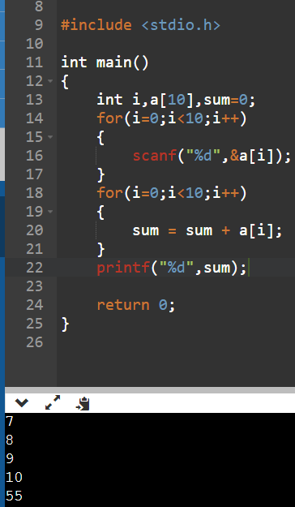

**Question – 2 Write a program to calculate the average of numbers stored in an array of size 10. Take array values from the user.**

**Ans.**

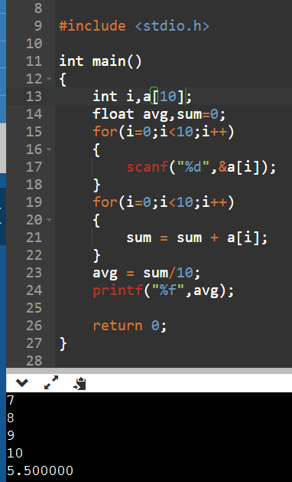

**Question – 3 Write a program to calculate the sum of all even numbers and sum of all odd numbers, which are stored in an array of size 10. Take array values from the user.**

**Ans.**

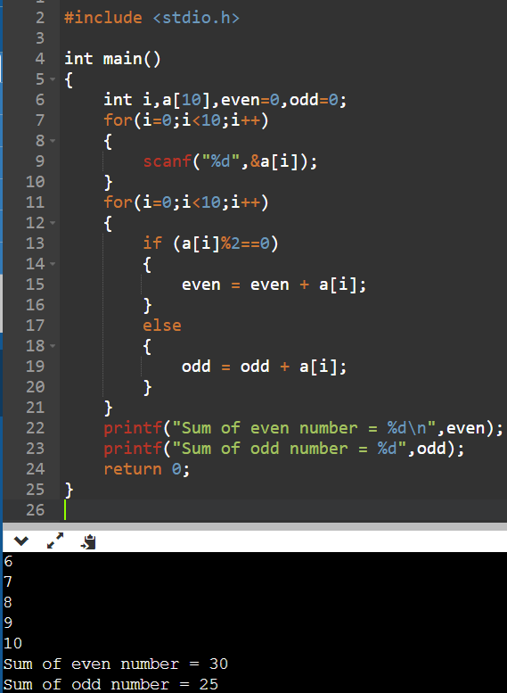

**Question – 4 Write a program to find the greatest number stored in an array of size 10. Take array values from the user.**

**Ans.**

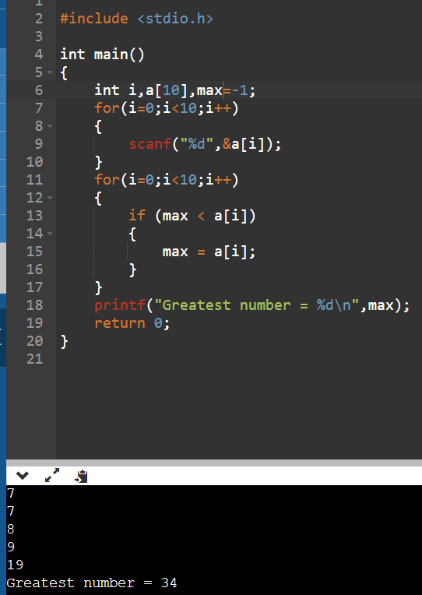

**Question – 5 Write a program to find the smallest number stored in an array of size 10. Take array values from the user.**

**Ans.**

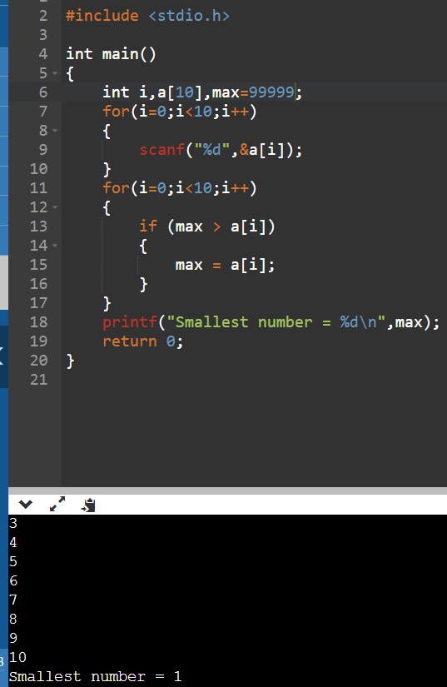

**Question – 6 Write a program to sort elements of an array of size 10. Take array values from the user.**

**Ans.**

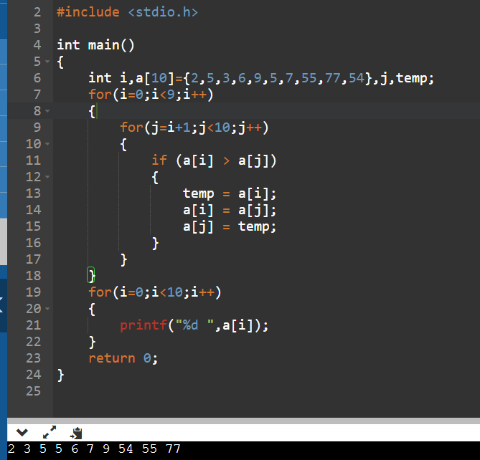

**Question – 7 Write a program to find second largest in an array.Take array values from the user.**

**Ans.**

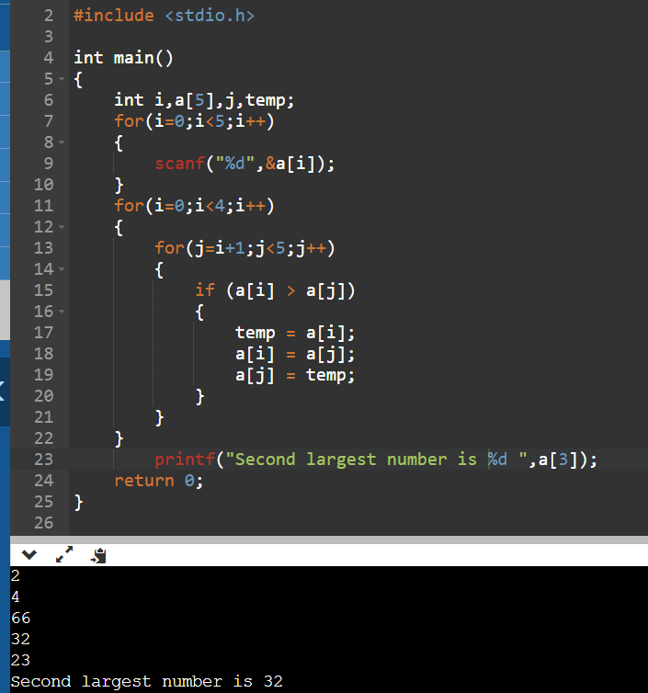

**Question – 8 Write a program to find the second smallest number in an array. Take array values from the user.**

**Ans.**

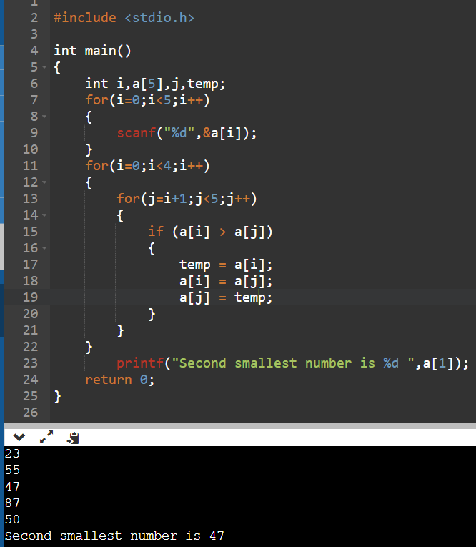

**Question – 9 Write a program in C to read n number of values in an array and display it in reverse order. Take array values from the user.**

**Ans.**

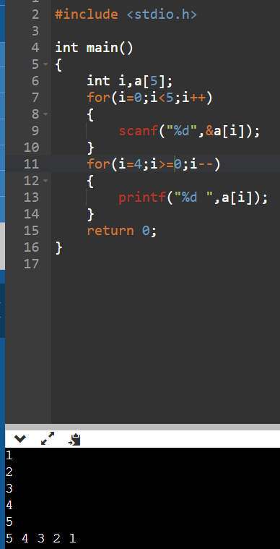

**Question – 10 Write a program in C to copy the elements of one array into another array. Take array values from the user.**

**Ans.**

